Node js installation

1.Unbock external script run (Set-ExecutionPolicy -Scope CurrentUser -ExecutionPolicy RemoteSigne)

2. intialise node.js(node init -y)

3.install packages (npm install express mongoose dotenv cors) (npm install --save-dev nodemon)

4.

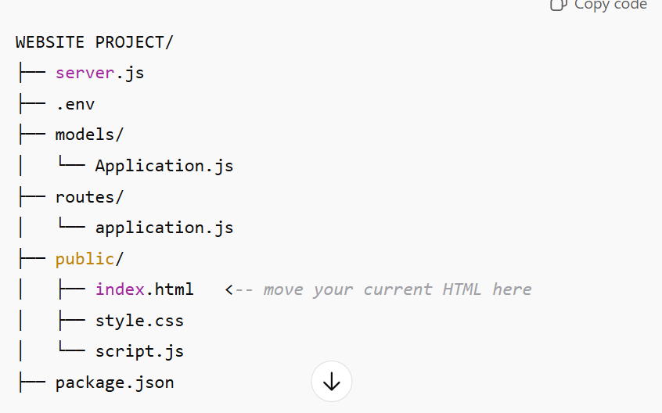

SERVER.JS CODE

require('dotenv').config();

const express = require('express');

const mongoose = require('mongoose');

const cors = require('cors');

const app = express();

app.use(cors());

app.use(express.json());

app.use(express.static('public'));

mongoose.connect(process.env.MONGO_URI)

.then(() => console.log('✅ MongoDB connected'))

.catch(err => console.error('❌ MongoDB connection error:', err));

const appRoutes = require('./routes/application');

app.use('/api/applications', appRoutes);

const PORT = process.env.PORT || 5000;

app.listen(PORT, () => console.log(`🚀 Server running on [http://localhost:${PORT}`)](http://localhost:$%7bPORT%7d%60)));

MONGO DB CONNECTION CODE (mongodb://127.0.0.1:27017)

RUN NODE JS SERVER (node server.js)

.ENV FILE (MONGO_URI=mongodb://127.0.0.1:27017/school-db)